Randy  Ludwig | Nelson  Huang | Cami  (Cameron)  Keene | Andrew Quon | Justin Quach | Nathan  Lam
Ariely  Gomez | x | Filip  (Tanadol)  Aueyong | Alice Chien | Haley Chen | Malia  Carr
Lauren Sargent | James Nagaoka | Tracy  Wang | Brendan  Kerr-Fretwell | Echo  (Wenxuan)  Gao | Travis  Hopf
Emilee  Killen | Jonathan Huang | Josh Kelly | Claudia  Nunez | Katelyn  Wong | Frank  Lin
Justin  Chu  THIS IS WHAT I USE, I LEAVE A BIT OF SPACE SO I CAN WRITE DOWN ATTENDANCE,  Bolded names are students who have to sit in the front (I consider the front the 1st three rows) | Iris  Yee | Stella  Saw | Jake  (Jacob)  Avila | Gabriel Moreano | Brianna  Chen
Joshua  Tan | Vanessa Bonilla | Andrea  Luna | Tangia  Sun | Clayton  Coe | Loreny Valdez
Back door
FRONT DESK
KUSO
Room S-104
_35____ Students Chemistry, _1st__period
Before I post the seating chart for students, I delete the legal names and get rid of the bold font.
Back door
Randy  Ludwig | Nelson  Huang | Cami  Keene | Andrew Quon | Justin Quach | Nathan  Lam
Ariely  Gomez | x | Filip  Aueyong | Alice Chien | Haley Chen | Malia  Carr
Lauren Sargent | James Nagaoka | Tracy  Wang | Brendan  Kerr-Fretwell | Echo  Gao | Travis  Hopf
Emilee  Killen | Jonathan Huang | Josh Kelly | Claudia  Nunez | Katelyn  Wong | Frank  Lin
Justin  Chu | Iris  Yee | Stella  Saw | Jake  Avila | Gabriel Moreano | Brianna  Chen
Joshua  Tan | Vanessa Bonilla | Andrea  Luna | Tangia  Sun | Clayton  Coe | Loreny Valdez
FRONT

This is what I display on the whiteboard (too much effort to drag and drop all the names), but I prefer it to be normally written:
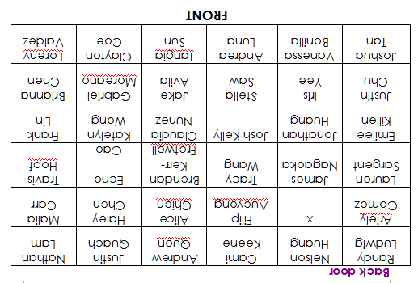
Seating chart example
(similar colors = “desk group”)

Boy  Entire desk group is empty if 32 students | Girl  Entire desk group is empty if 32 students | Boy | Girl  (*) | Boy | Girl
Girl  Entire desk group is empty if 32 students | Boy  Empty if 35 students  Entire desk group is empty if 32 students | Girl | Boy  (*)  Empty if 34 students | Girl  Empty if 33 students | Boy
Boy | Girl | Boy | Girl  (*) | Boy | Girl
Girl | Boy | Girl | Boy  (*) | Girl | Boy
Boy  Middle/high test score | Girl  Middle/high test score | Boy  Middle/high test score | Girl  (*)  Middle/high test score | Boy  High test score | Girl
Girl  Higher test score | Boy  lower test score | Girl  High test score | Boy  (*column 4, moves to lab area on test day – will not sit in this row the next seating chart)  lower test score | Girl  Highest test score | Boy  lowest test score (might not be a boy, so just alternate boy/girl)

FRONT OF ROOM

